Goal
The primary objective is to build capital for N/LAB Banking by marketing their N/LAB Platinum Deposit financial product that offers an attractive fixed-term interest rate, requires a sizeable deposit, and restricts withdrawals for a minimum of one year. The Chief Development Officer (CDO) has emphasized the importance of avoiding unproductive calls to uninterested individuals due to costly staff time expenditure.
Summarization
The Output Variable
The output variable, 'y', indicates whether a call resulted in a sale ('yes' indicates a sale, 'no' indicates no sale). The dataset comprises 4,000 total observations, with 3,153 negative responses (79%) and 847 positive responses (21%). This 21% represents the baseline "yes rate." Within this analysis, the term "baseline yes rate" references the mean rate of positive sales responses across the 4,000 data points supplied by NLAB Banking. The 'yes rate' is calculated as total positive responses divided by total responses, while the 'no rate' represents total negative responses divided by total responses.
Key Variables and Initial Observations:
A comprehensive analysis was conducted beginning with basic summary statistics for all variables. Multiple visualization methods were employed: frequency tables for categorical variables, and histograms and box plots for numerical variables. This systematic approach established a baseline understanding of feature frequencies within the dataset and their relationships with the output variable.
Additionally, to observe relationships between the input variables, a correlation matrix was developed and some of the most important variables were visualized against one another, providing crucial insights for model parameter configuration. The analysis revealed several significant patterns that informed subsequent modeling decisions.
What follows is a summary of each variable, its significance within the confines of our initial variable exploration, and any additional findings regarding the variables. Some visualizations are provided for variables of particular importance. Each variable is listed below, and all variables are ordered by most to least significant.
Variables of Significance:
Poutcome (Previous Outcome) represents the result of previous campaign sales attempts. Analysis revealed this variable to be critical in predicting purchase likelihood. Customers with a 'success' outcome demonstrated an 83% buy rate, representing a 62% increase from the baseline rate. This finding suggests that customers who previously purchased through telemarketing strategies show significantly higher likelihood of future purchases. Conversely, customers with a 'failure' outcome showed only a 22% success rate, with 'unknown' or 'other' outcomes displaying similarly low rates.
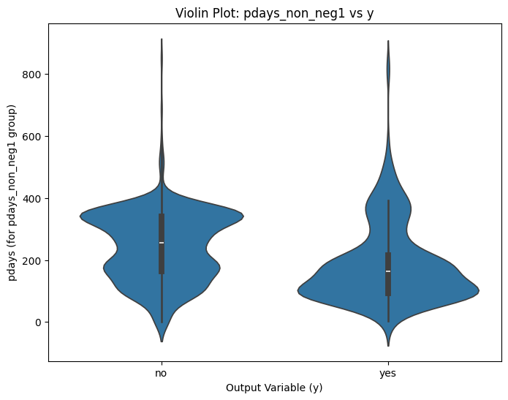
Pdays (Previous Days) represents the time elapsed since the last contact in a previous campaign. The variable contains two distinct groups: -1 indicating no previous contact (80% of observations), and positive numbers indicating days since last contact. Further analysis required splitting into pdays_-1 and pdays_nonnegative categories, revealing that recently contacted customers showed significantly higher purchase likelihood. The data demonstrated that optimal contact timing falls between 50-200 days, with effectiveness declining beyond this window. Customers who have never previously been contacted (Pdays = -1) were much less likely to purchase the product.
Figure 1: Violin Graph Showing Pdays' Ideal Range (50-200 Days Between Contact)
Previous indicates the number of contacts to the customer before this campaign. Analysis revealed that customers who were previously contacted at least once were much more likely to respond positively to this campaign than customers who had never been contacted. A similar approach was taken with Previous as to Pdays, but it was found that splitting this variable into Previous_0 and Previous_non0 groups did not yield additional insights beyond the initial findings.
Duration represents last contact duration in seconds. Although showing high significance, further investigation revealed inherent bias. Zero duration indicates no contact and thus automatic negative response. What was revealed though, was that for calls with duration greater than zero, longer conversations correlated with higher success rates. Due to its inherent unavailability for predictive purposes with future customers and calls, this variable was excluded from future-focused models.
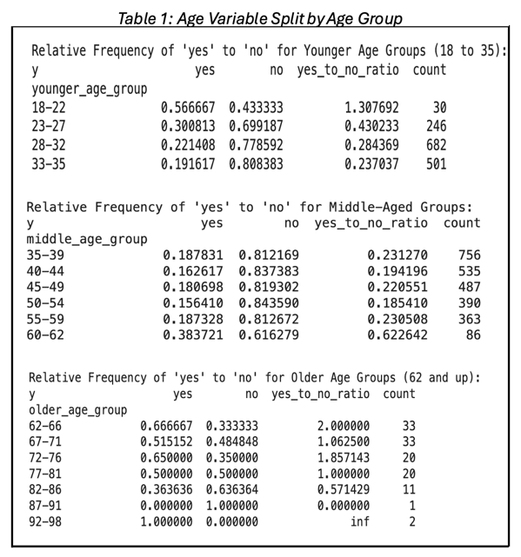
Age initially showed no significance against the output variable, but upon further analysis this variable was portraying a bias towards the mean. Age demonstrated significant patterns when analyzed in groups. Initial analysis appeared unremarkable, with a mean age of 41 and median of 39. However, deeper investigation of unweighted age groups revealed distinct patterns: the 62-66 age group showed the highest positive response rate at 67%, with all groups between 62-81 years maintaining rates above 50%. The 18-22 age group also showed notably positive response rates at 51%. Middle-aged groups demonstrated significantly lower response rates, with the 40-44 age group showing only 16% success.
Job revealed unexpected patterns contrary to initial assumptions regarding income and stability. Students showed the highest positive response rate at 41%, followed by retirees at 37%. Despite their high success rates, these groups represented only 10% of the total population. Blue-collar workers showed the lowest positive response rate at 15%, followed by entrepreneurs, housemaids, and self-employed at approximately 16%. These lower-performing groups comprised 30% of the total population, indicating significant opportunity for targeting optimization.
Housing and Loan variables, defined as the presence of an outstanding house or personal loan respectively, demonstrated correlation with response rates. Customers without housing loans showed a 29% positive response rate versus 14% for those with housing loans. Similarly, individuals without personal loans responded positively 22% of the time versus 14% for those with loans. This pattern suggests financial obligations significantly impact product interest.
Education demonstrated a positive correlation between higher education levels and investment likelihood, with approximately 10% difference in positive response rates between lowest and tertiary education levels.
Balance showed relatively low significance despite initial assumptions of its importance. The mean balance of $1,402 versus median of $488 indicated significant skew, suggesting most observations cluster near zero with notable outliers creating left-skewed distribution. Because of this bias in observations, balance will be scrutinized for significance later in the modelling section as it intuitively should affect the outcome variable.
Insignificant Variables:
Marital Status showed statistically insignificant variations, though single customers did show slightly higher ‘yes rates.’
Default provided limited analytical value as only 1.5% of the available population had a known default on their record with the bank. This makes the variable heavily biased towards the other responses and makes any interpretation of the variable debatable.
Contact, Day, and Campaign variables showed minimal correlation with outcomes.
Relationships Among Input Variables:
A strong positive correlation between Previous and Pdays was shown. This was likely to be the case given the nature of the definitions of the variable. This does not nullify any significance of either variable, but it will help correctly parameterize the models in later sections. It must be noted that some variables display strong correlation and this correlation will need to be corrected for models that assume no collinearity. A positive correlation between age and marital status was also found in the correlation matrix.
The matrix also revealed a negative correlation between Poutcome and both Previous and Pdays. This indicates that Poutcome is inversely correlated with Previous and Pdays.
Upon analysis of the interactions between input variables, it was found that extended call durations aligned with higher previous success rates. People who are willing to stay on the phone are people who are more likely to buy. Higher contact frequencies correlated with reduced success likelihood. Persistent calling may be disliked by customers.
Summarization of Initial Variable Exploration:
The analysis identified Poutcome, Pdays, and Previous as the most impactful variables, indicating that existing customers with previous contact history demonstrated higher purchase likelihood. Among demographic variables, age, job, and loan status emerged as key predictors. The optimal target segments were identified as young students (18-22) and retirees (62-81) without outstanding loans, while middle-aged blue-collar workers with outstanding loans showed the lowest response rates.
Extended call durations correlated positively with success rates, while excessive contact frequency demonstrated negative impact. This suggests optimal engagement strategies should focus on quality of contact rather than quantity.
Exploration: Decision Tree Analysis
The decision tree's root split occurs on the 'pdays' variable, with a threshold of 11.0. This divides customers based on whether they have been previously contacted (pdays > 11.0) or not (pdays ≤ 11.0). Following this initial split, the tree branches based on several key variables: 'contact' (threshold 1.5) and 'age' (threshold 43.5) on the left branch, while the right branch splits on 'poutcome' (threshold 1.5) and 'housing' (threshold 0.5).
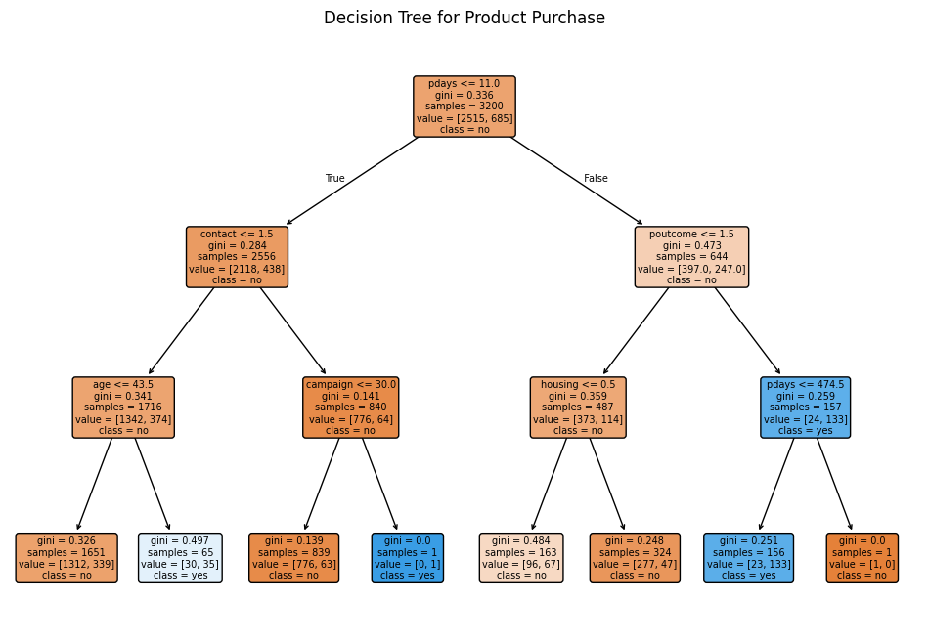
Figure 2: First Iteration Decision Tree (Without Duration)
The most significant split appears to be the one on 'poutcome <= 1.5' in the right branch. This split is particularly noteworthy because it leads to one of the purest classifications in the tree (indicated by the blue node with pdays <= 474.5). This suggests that the combination of customers who have been previously contacted but not in the last 11 days (passing the root split) and have a certain previous outcome of success are highly predictable in terms of their purchasing behavior. The purity of this split, combined with its relatively large sample size (644 samples), indicates that previous campaign outcomes are strongly predictive of future purchase decisions.
More decision trees were created to further explore the variables and their significance, as well as important subpopulations, but the results will be specified more thoroughly in the following section where the decision tree is evaluation as a classification model.
Model Evaluation
Three models were selected for evaluation based on their ability to handle the data present:
Logistic regression offered strong interpretability and compatibility with categorical variables of which we have many. The model required removal of highly collinear features to prevent multi-collinearity issues, so it was necessary to remove some variables from the analysis. Limitations included sensitivity to outliers and assumption of linear relationships between variables. These limitations may prove inadmissible, since our dataset does contain many variables with outliers and variables that seem non-linear in nature.
The decision tree provided intuitive interpretation and robust handling of non-linear relationships. While enabling quick creation of interpretable models showing variable relationships and important subpopulations, the risk of overfitting increased with pursuit of higher precision. High precision is what the goal of the model is after, so it may prove ineffective as the final model.
The random forest model exhibited particular strength in handling imbalanced data while maintaining resistance to overfitting. This feature is crucial as the data available is quite imbalanced, especially the most important outcome variable. Random Forest is a robust model and seems to suit the data-set well under its current conditions.
Evaluation Strategy
Models were evaluated using accuracy, precision, and recall, and their overall confusion matrix with a heightened emphasis on precision to minimize unproductive calls.
Results and Final Assessment
Each model demonstrated distinct performance characteristics:
Logistic regression achieved high precision but inadequate recall scores due to data non-linearity. Even after manipulation of input variables like excluding additional variables and logging variables, the model was not up to standard for this dataset.
Decision Tree provided valuable initial insights but showed overfitting tendencies at higher precision levels. The model yielded some very interesting insight initially but was not robust enough to make accurate future predictions. The model was able to shed light on interesting subpopulations in the data, but was not precise enough to accurately predict who would respond yes or no with certainty. We only found near-pure nodes if we split the tree many times, which is an indicative feature of over-fitting our model.
In attempts to get the most out of this model and use its flexibility to the analysis’ advantage, many iterations of the decision tree model were employed. One of the most fruitful iterations was a decision tree that only analyzed demographic data. This model showed that, among demographic data, age, job, and housing were all important variables and shed more insight onto their importance and relation to one another and the output variable.
This was the main benefit of the decision tree model, its ease of reproducibility and flexibility. This benefit did not outweigh its drawback inability to accurately predict outcomes.
Random Forest achieved the highest 86% precision with a relatively low 20% recall, excelling at negative response prediction. The negative response prediction is the most important in this particular use case, and there are ways to raise this recall by altering parameters.
The Random Forest model was selected as optimal, for these reasons. From 4,000 observations, the model identified 169 target customers, projecting 146 successful sales. With further parameterization, the model can produce many more target customers while only sacrificing small percentages of precision and accuracy. This model provides the best interplay of precision, robust, flexibility, and ability to use the specific data types present in the available dataset.
Model Implementation
The implemented Random Forest model provides N/LAB Banking with a flexible, user-friendly tool for customer evaluation. Key strengths include:
- Minimal steps required from data input to actionable customer lists
- Adaptability to new variable sets through simple retraining procedures
- Sliding scale functionality allowing precision-recall trade-off optimization
- Each 0.05 threshold reduction yields approximately 5% recall increase for 5% precision decrease
Instructions for New Data:
- Open up an instance of the model
  - Ensure you are on the “User Friendly Model Trained on Entire Dataset”
- Upload your csv file to the server
  - Go to Files Click: “Upload to Session Storage” Upload your dataset
- Load New data under the “STEP 1: Load new data” Text Box.
  - Replace the CSV name with your new data’s csv file extension
- Ensure column names are correctly referenced, and encode the variables that are categorical in nature
  - Under X data in STEP 2A, you can choose which variables from your data-set to include in the analysis. It is recommended you use all variables available.
  - Under Y data in STEP 2A, you choose your output variable.
    - Ensure that all variable names match exactly. You can check your variable names by running the ‘code.head’ chunk provided directly above “STEP 2”
  - For each categorical variable you are going to use, include it in the list under STEP 2B to ensure that the variables are encoded numerically so our model can interpret the data
- Make sure you have ran the chunks from STEP 1 and STEP 2, and now you can run the model in STEP 3
  - If you wish to retrain the model using new data, set retrain = True and pass the new dataset to the newly trained model
  - If you wish to use the old model on new data, set retrain = False and pass the new data to the old model (this requires you to have run at least 1 model to have an ‘old model’)
- The model will run, and you can read the output. You will be given the option to run the model again with a lower threshold (‘yes’), terminate the instance of the model (‘terminate’), or export the resulting prediction list to a .csv (‘export’).
- If you choose ‘yes’ the model will iterate again at a lower threshold, providing new customers to contact. You can keep choosing yes until the desired number of potential calls is reached, or until the desired threshold/precision level is reached.

Business Case Recommendations
The model should be implemented across all existing customer databases. It should be retrained regularly with new and larger data sets. Another benefit of this model is that it can become more and more accurate with each additional datapoint provided. Currently, its recall is quiet low, but this is because our training data has so few ‘yes’ observations and is biased towards the ‘no’ class. With more data points, our recall score has exceptional potential to increase. The model’s threshold level should be adjusted according to need. The first group iterated from the model should be used foremost, then as new customers are needed for contact the second iteration group should be used and so on.
N/LAB should prioritize previously sold-to customers first. Demographically, they should focus on retired individuals and students. They should also aim to contact customers somewhere between 50 and 200 days after the last previous contact. Any more is seen as incessant and unwarranted, any less is too few and far between.
Additionally, NLAB should develop separate strategies for new customers lacking historical internal interaction points of data. It was shown that many of the most important features rely on customers having previous interactions with the company, so it could be of benefit to retrain this model using only demographic data, or finding another model that suits the needs of a more refined, demographic only strategy.
In terms of long-term goal, N/LAB should consider young adult recruiting initiatives. Focusing on recruiting new customers that are of the target demographics could be of great benefit to the longevity and success of the company. This is especially true for young adults and students. By doing this, N/LAB would have the opportunity to create lifelong customers that have experience with purchasing N/LAB products at a young age. Additionally, N/LAB should look into creating a system that optimally contacts customers within the specified ideal time frame.
Potential Future Analysis:
Further research opportunities include:
- Detailed segmentation analysis of high-performing subpopulations
- Model enhancement through expanded training data
- Development of specialized models for new customer acquisition
- Investigation of additional demographic and behavioral indicators

